**Website:** [**https://zeencollagen.com/**](https://zeencollagen.com/)

**Dated: 06/02/2020**

**PRROPOSAL FOR SEO/SMO/PPC**

**Improve Ranking and boost your site Traffic we will be doing below activities:**

**SEO includes 2 Process:**

**1. ON PAGE OPTIMIZATION:**

**2. OFF PAGE OPTIMIZATION:**

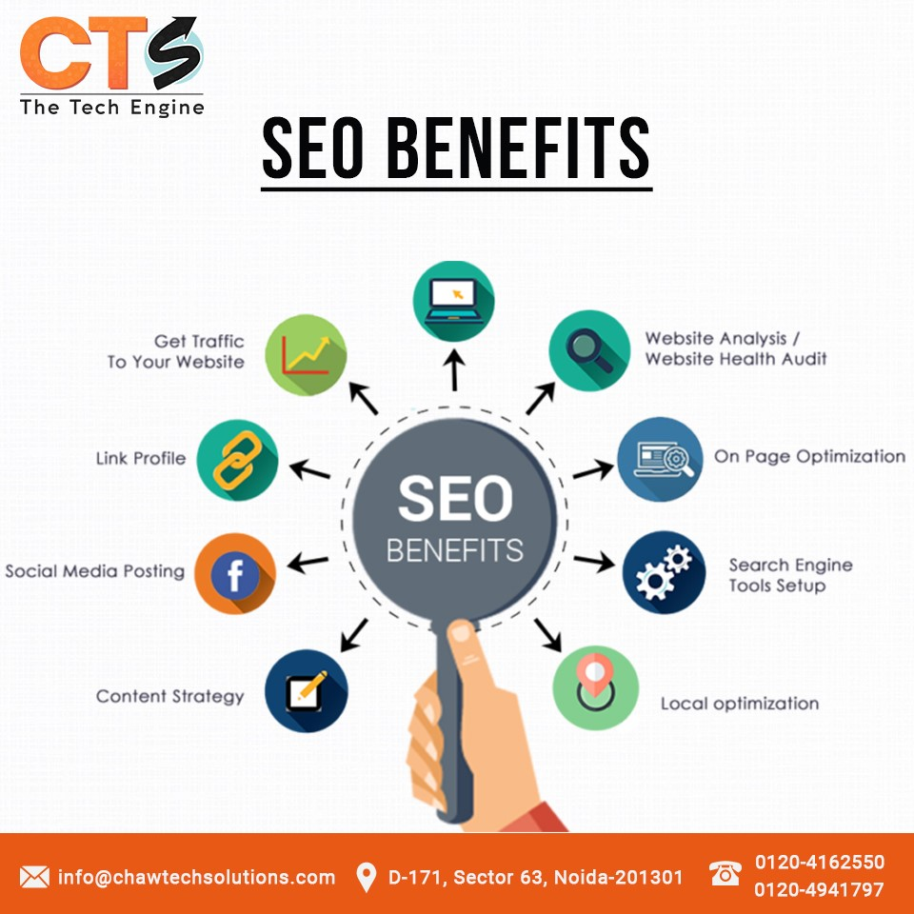

**ON PAGE OPTIMIZATION INCLUDES BELOW ACTIVITIES:**

1. **Keyword’s Research and Mapping**
2. **Competition Analysis and Website Audit**
3. **Robots.txt Optimization:**

**This file is responsible for controlling the web crawlers from accessing, crawling or indexing your website.**

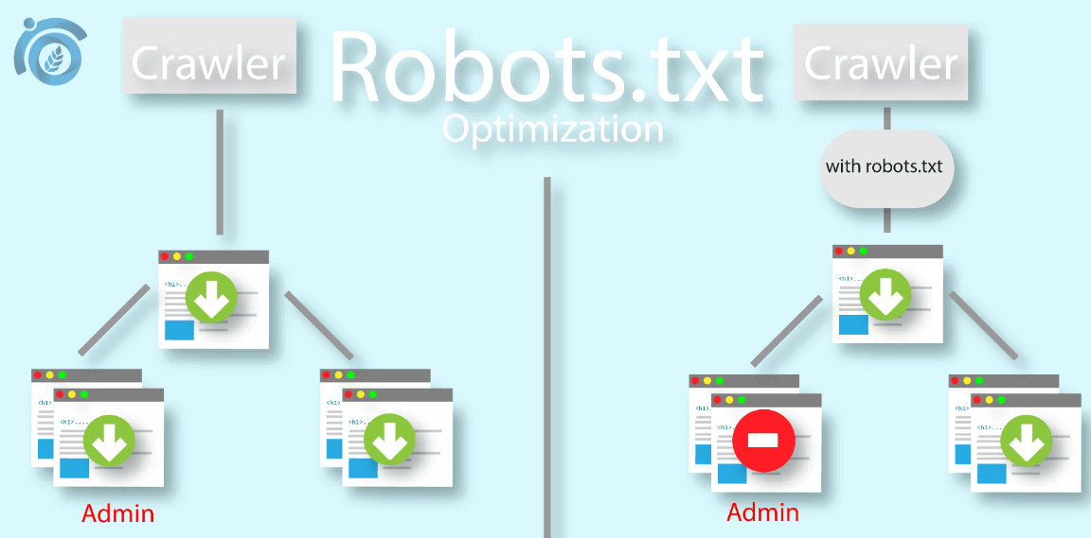

1. **Sitemap Optimization**
2. **Crawling and Indexing Issues Fix**
3. **Avoiding Crawl Traps**
4. **Title Optimization**
5. **Meta Description**
6. **Toxic Backlinks Disavow**
7. **Anchor Text Optimization**
8. **Keyword Density**
9. **Broken Link Analysis**
10. **Location demographics**
11. **Canonicalization**
12. **Architectural Taxonomy:**
13. **Semantic Proximity**
14. **URL Optimization**
15. **Search Friendly URL Structure and Parameters:**
16. **Crawl Budget and Index Bloat Optimization:**
17. **Image Optimization**
18. **Backlink Analysis**
19. **Favicon Test**
20. **Site Loading Speed Test**
21. **Inline CSS Test**
22. **Google analytics**
23. **Google search console**
24. **Content Optimization**

* **Mixed Content Issues**
* **Thin Content Issues**

**OFF PAGE OPTIMIZATION**

**Off page optimization includes below activities**

**Advanced Link Building:**

**Traditional link building practices involve different types of off-page submissions such as:**

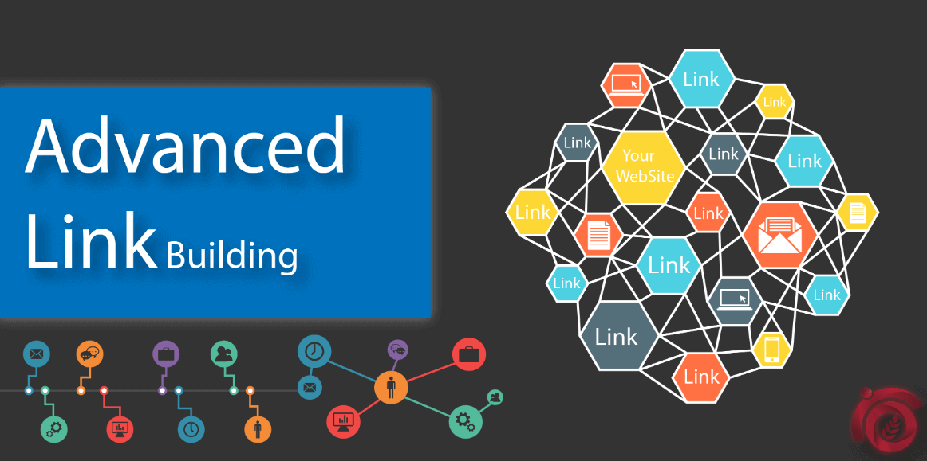

1. **Bookmarking**
2. **Classifieds**
3. **Business Listings**
4. **Social Submissions**
5. **PPT and PDF submissions**
6. **Image and Info-graphic submissions**
7. **WEB 2.0**
8. **Blog Submission**
9. **Directory Submission**
10. **Article Submission**

**SOCIAL MEDIA STARTEGY**

**SMO includes Below Activities:**

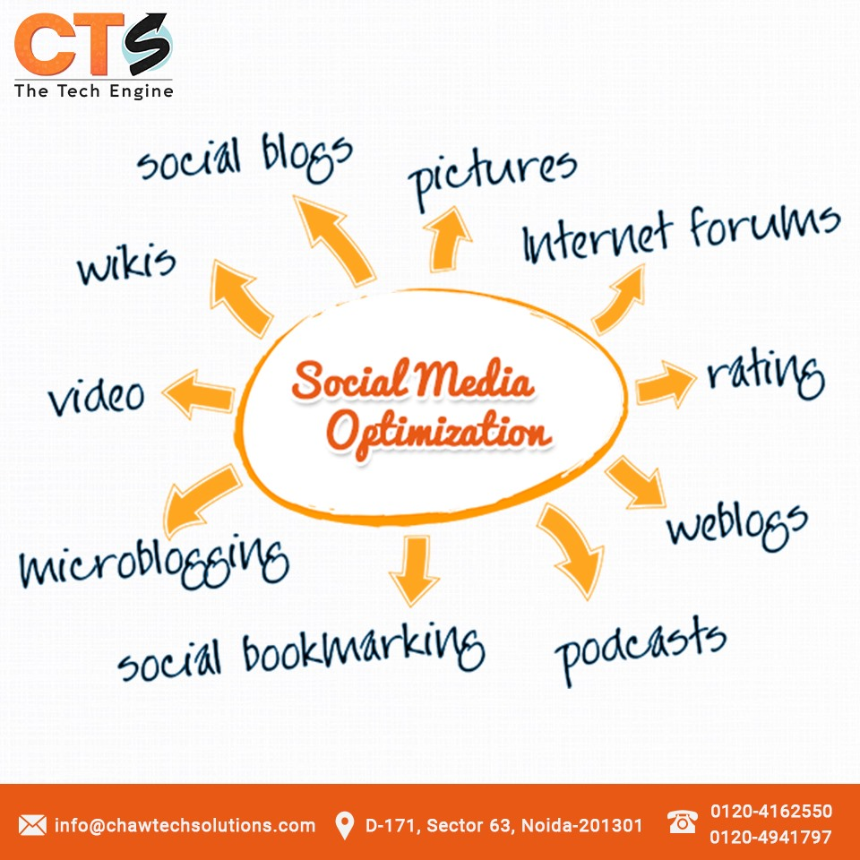

1. **Facebook Page creation**
2. **Facebook page likes**
3. **Twitter page creation**
4. **Twitter followers**
5. **LinkedIn Account creation**
6. **LinkedIn company page creation**
7. **Instagram**
8. **Video Marketing**

**Advantages of doing social media marketing:**

* **Social media posts can be used to drive targeted traffic**
* **Using social media for business boosts your site’s SEO**
* **If you’re doing it right, social media will lead to real relationship building**
* **Users are receptive to your messages**
* **Social media ads allow targeting and retargeting**
* **Social media can help you get noticed at events, and even generate earned media coverage**
* **You can respond to problems immediately**

**PROPOSAL FOR PPC**

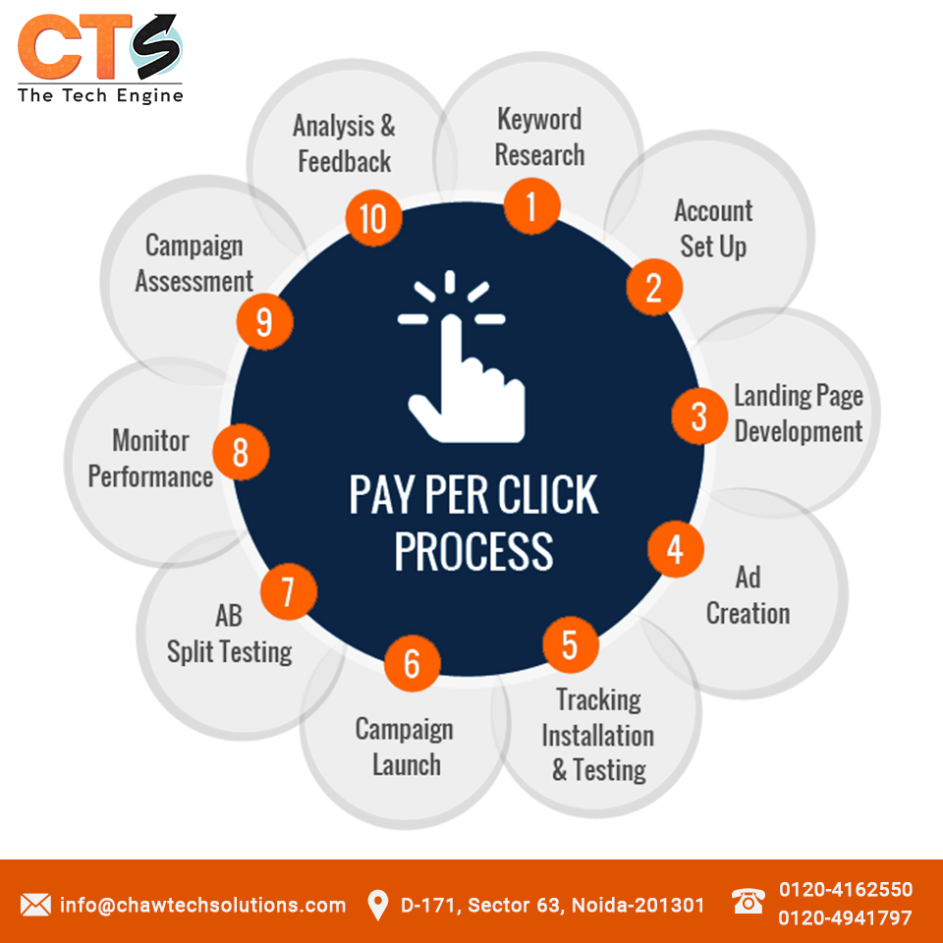

## Pay per Click (PPC) Campaign Management Process

1. **Set Goals.**
2. **Categorize Services/Products**
3. **Advanced keyword research and selection.**
4. **Account Setup.**
5. **Custom Landing Page Design**
6. **Landing Page Mapping**
7. **Optimized Ad Creation**
8. **PPC Campaign Conversion Tracking**
9. **Choose Where To Advertise.**
10. **Set Your Advertising Budget.**
11. **Set Your Bids.**
12. **Write Your Ad Copies.**
13. **PPC Monthly Analysis & Reporting**
14. **PPC Campaign Assessment and Recommendations**

**------------------------------------------------- End of Document----------------------------------------------------**